Create A Countdown Timer Using Python

**Code**

import time

from tkinter import *

import multiprocessing

from tkinter import ttk, messagebox

from playsound import playsound

from threading import *

# Hour list

hour_list = [0, 1, 2, 3, 4, 5, 6, 7, 8, 9, 10, 11, 12, 13, 14,

15, 16, 17, 18, 19, 20, 21, 22, 23, 24]

# Minute List

min_sec_list = [0, 1, 2, 3, 4, 5, 6, 7, 8, 9, 10, 11, 12, 13, 14,

15, 16, 17, 18, 19, 20, 21, 22, 23, 24, 25, 26, 27, 28, 29,

30, 31, 32, 33, 34, 35, 36, 37, 38, 39, 40, 41, 42, 43, 44,

45, 46, 47, 48, 49, 50, 51, 52, 53, 54, 55, 56, 57, 58, 59,

]

# Creating a CounDown Class

class CountDown:

def __init__(self, root):

self.window = root

self.window.geometry("800x600+0+0")

self.window.title('CountDown Timer')

# Tkinter window background color

self.window.configure(bg='lime')

# Fixing the Window length constant

self.window.resizable(width = False, height = False)

# Declaring a variable to pause the countdown time

self.pause = False

# The Start and Pause buttons are placed

# inside this frame

self.button_frame = Frame(self.window, bg="lime", \

width=240, height=40)

self.button_frame.place(x=230, y=150)

# This frame is used to show the countdown time label

self.time_frame = Frame(self.window, bg="lime", \

width=480, height=120).place(x=0, y=210)

# Tkinter Labels

time_label = Label(self.window, text="Set Time",

font=("Vardana",25, "bold"), bg='gray35',fg='yellow')

time_label.place(x=220, y=20)

hour_label = Label(self.window, text="Hour",

font=("times new roman",20), bg='gray35', fg='white')

hour_label.place(x=100, y=80)

minute_label = Label(self.window, text="Minute",

font=("times new roman",20), bg='gray35', fg='white')

minute_label.place(x=240, y=80)

second_label = Label(self.window, text="Second",

font=("times new roman",20), bg='gray35', fg='white')

second_label.place(x=400, y=80)

# ===========================================

# Tkinter Comboboxes

# Combobox for hours

self.hour = IntVar()

self.hour_combobox = ttk.Combobox(self.window, width=8,

height=10, textvariable=self.hour,

font=("times new roman",18))

self.hour_combobox['values'] = hour_list

self.hour_combobox.current(0)

self.hour_combobox.place(x=100,y=120)

# Combobox for minutes

self.minute = IntVar()

self.minute_combobox = ttk.Combobox(self.window, width=8,

height=10, textvariable=self.minute,

font=("times new roman",18))

self.minute_combobox['values'] = min_sec_list

self.minute_combobox.current(0)

self.minute_combobox.place(x=240,y=120)

# Combobox for seconds

self.second = IntVar()

self.second_combobox = ttk.Combobox(self.window, width=8,

height=10, textvariable=self.second,

font=("times new roman",18))

self.second_combobox['values'] = min_sec_list

self.second_combobox.current(0)

self.second_combobox.place(x=400,y=120)

# ===========================================

# Tkinter Buttons

# Set Time Button

# When the user will press this button

# the 'Start' and 'Pause' button will

# show inside the 'self.button_frame' frame

set_button = Button(self.window, text='SET',

font=('Helvetica',16 , "bold"), bg="white", fg="black",

command=self.Get_Time)

set_button.place(x=160, y=230)

# Cancel button

cancel_button = Button(self.window, text='CANCEL',

font=('Helvetica',16 , "bold"), bg="white", fg="black",

command=self.Cancel)

cancel_button.place(x=280, y=230)

# It will destroy the window

def Cancel(self):

self.pause = True

self.window.destroy()

# When the set button is pressed, this

# function gets called

def Get_Time(self):

self.time_display = Label(self.time_frame,

font=('Helvetica', 30 , "bold"),

bg = 'red', fg = 'yellow')

self.time_display.place(x=130, y=300)

try:

# Total amount of time in seconds

h = (int(self.hour_combobox.get())*3600)

m = (int(self.minute_combobox.get())*60)

s = (int(self.second_combobox.get()))

self.time_left = h + m + s

# If the user try to set the default time(0:0:0) then

# a warning message will display

if s == 0 and m == 0 and h == 0:

messagebox.showwarning('Warning!',\

'Please select a right time to set')

else:

# Start Button

start_button = Button(self.button_frame, text='Start',

font=('Helvetica',15), bg="green", fg="white",

command=self.Threading)

start_button.place(x=10, y=5)

# Pause Button

pause_button = Button(self.button_frame, text='Pause',

font=('Helvetica',15), bg="red", fg="white",

command=self.pause_time)

pause_button.place(x=70, y=5)

except Exception as es:

messagebox.showerror("Error!", \

f"Error due to {es}")

# Creating a thread to run the show_time function

def Threading(self):

# Killing a thread through "daemon=True" isn't a good idea

self.x = Thread(target=self.start_time, daemon=True)

self.x.start()

# It wil clear all the widgets inside the

# 'self.button_frame' frame(Start and Pause buttons)

def Clear_Screen(self):

for widget in self.button_frame.winfo_children():

widget.destroy()

def pause_time(self):

self.pause = True

mins, secs = divmod(self.time_left, 60)

hours = 0

if mins > 60:

# hour minute

hours, mins = divmod(mins, 60)

self.time_display.config(text=f"Time Left: {hours}: {mins}: {secs}")

self.time_display.update()

# When the Start button will be pressed then,

# this "show_time" function will get called.

def start_time(self):

self.pause = False

while self.time_left > 0:

mins, secs = divmod(self.time_left, 60)

hours = 0

if mins > 60:

# hour minute

hours, mins = divmod(mins, 60)

self.time_display.config(text=f"Time Left: {hours}: {mins}: {secs}")

self.time_display.update()

# sleep function: for 1 second

time.sleep(1)

self.time_left = self.time_left -1

# When the time is over, a piece of music will

# play in the background

if self.time_left <= 0:

process = multiprocessing.Process(target=playsound,

args=('Ringtones/Clock Alarm.mp3',))

process.start()

messagebox.showinfo('Time Over','Please ENTER to stop playing')

process.terminate()

# Clearing the 'self.button_frame' frame

self.Clear_Screen()

# if the pause button is pressed,

# the while loop will break

if self.pause == True:

break

if __name__ == "__main__":

root = Tk()

# Creating a CountDown class object

obj = CountDown(root)

root.mainloop()

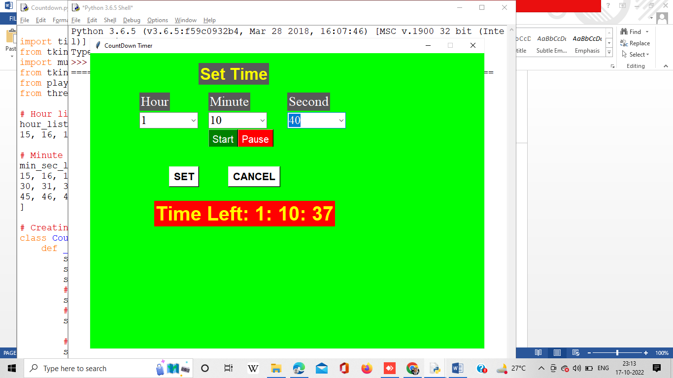**Output**